D

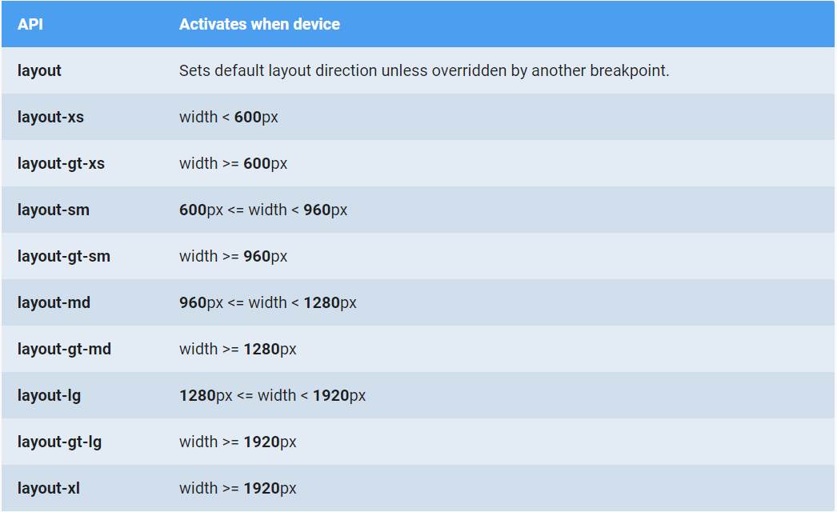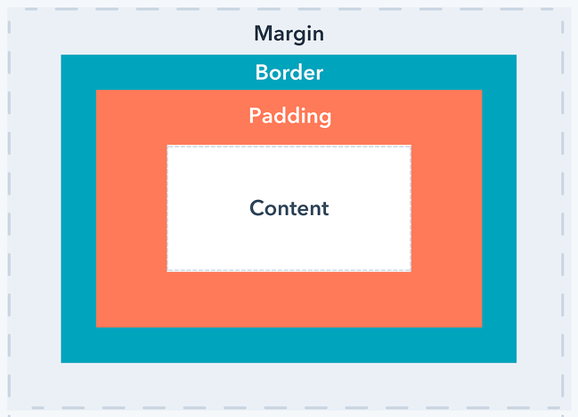<https://github.com/angular/flex-layout/wiki/fxShow-API>

<https://material.angularjs.org/latest/layout/options>

<https://www.digitalocean.com/community/tutorials/angular-flex-layout>

<https://www.excellarate.com/blogs/getting-started-with-angular-flex-layout/#:~:text=Angular%20Flex%2DLayout%20is%20a,for%20use%20in%20your%20templates>.

https://tburleson-layouts-demos.firebaseapp.com/#/issues